**ELEC-E7250 - Laboratory Course in Communications Engineering**

Measurement report: Spectrum analyzer and Measurements Automatization

Group members: Xingji Chen and Zheyuan Liu

**Spectrum analyzer**

1. **Using spectrum analyzer**
2. Set the oscilloscope input impedance to be 50 Ω. Find the signal with the oscilloscope. The oscilloscope shows the signal voltage. Give the equation that relates this value to the power level set at the signal generator.

In linear scale



In dB scale



1. Use spectrum analyzer and find the signal by selecting suitable center frequency and span.

How and why the spectrum analyzer displayed image differs from the oscilloscope image?

What is the maximum power of the signal?

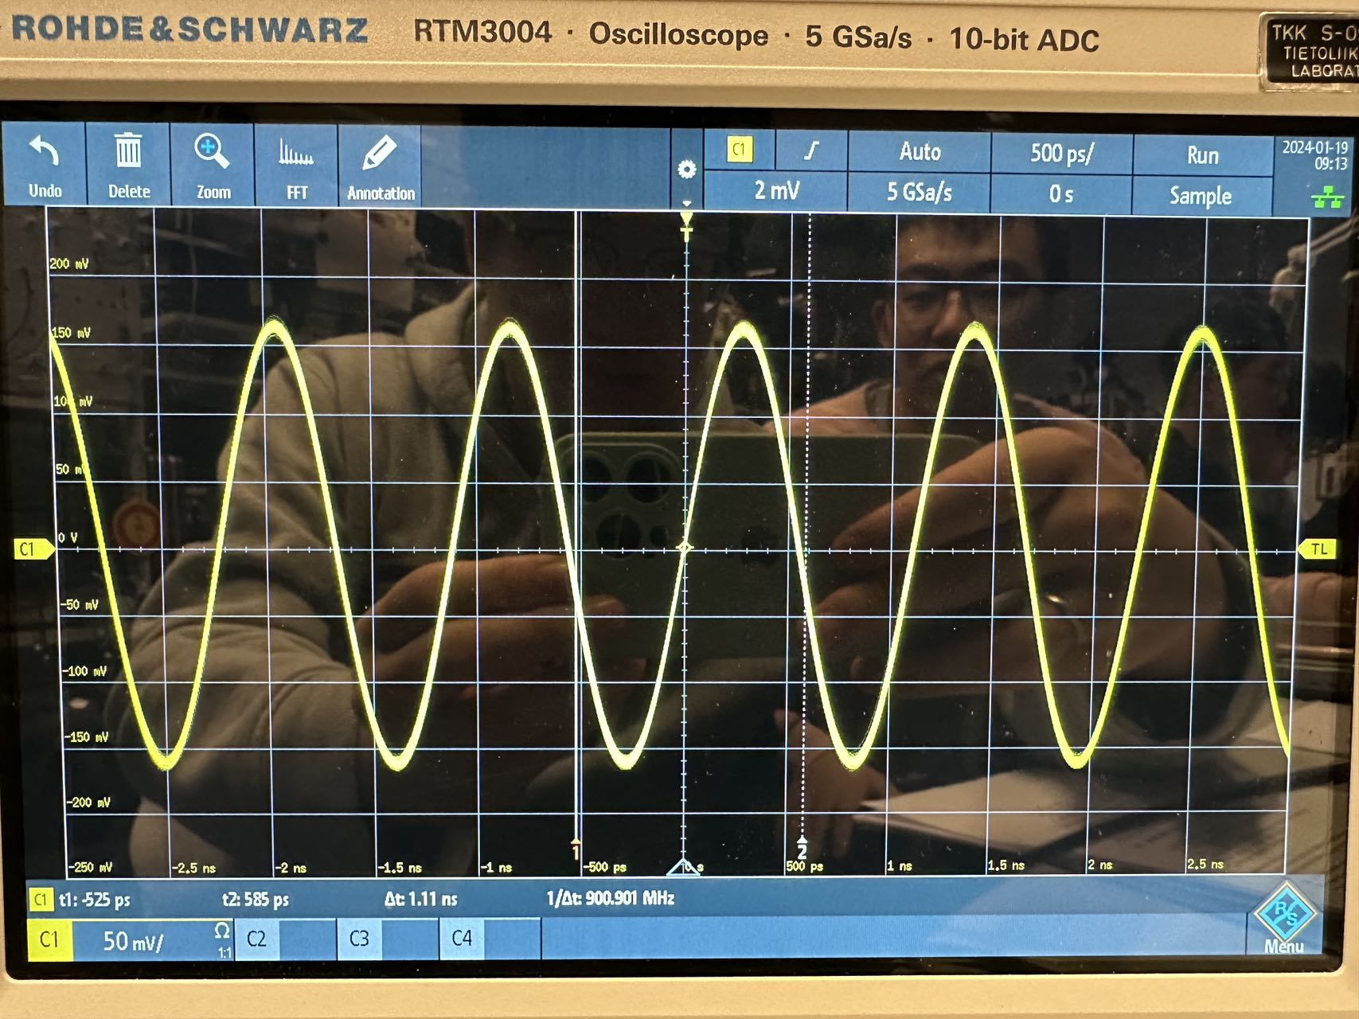

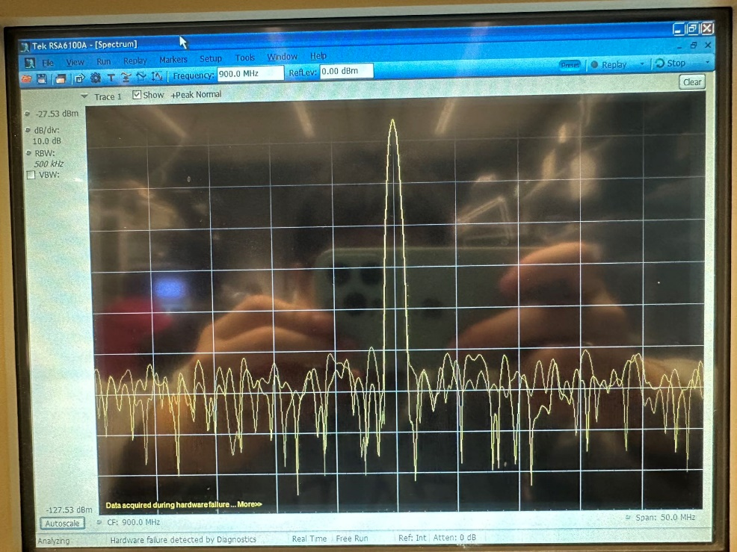

The suitable center frequency is 900 MHz and the span is 50 MHz.

Oscilloscope shows time-domain information. It displays how a signal changes over time, typically showing voltage vs. time.

Spectrum analyzer shows frequency-domain information. It displays how signal power is distributed across different frequencies, typically showing power vs. frequency.

The maximum power of the signal is -32.59 dBm.

1. Sketch the theoretical spectrum of the sinusoidal input signal.

How the spectrum shown by spectrum analyzer differs from the theoretical spectrum?



The differences between the spectrum displayed by a spectrum analyzer and the theoretical spectrum mainly stem from practical operation and equipment limitations. These differences include the limitations of resolution bandwidth, the sensitivity and noise floor of the device, limited dynamic range, issues with frequency accuracy and stability, as well as potential harmonics and spurious responses. Additionally, actual measurements are influenced by antenna and cable losses, and issues related to windowing and leakage in FFT-based analyzers. Overall, the spectrum analyzer provides a spectral view that takes into account the limitations and environmental factors of real-world measurement systems, presenting a more complex and varied picture compared to the idealized, noise-free, and distortion-free theoretical spectrum.

1. Change the resolution bandwidth:
2. Hz, 100 KHz, 10 KHz, 1KHz, 100 Hz.

Comment how the resolution bandwidth impacts the spectrum plot?

Give the numerical values of the resolution bandwidth and the observed spectrum change.

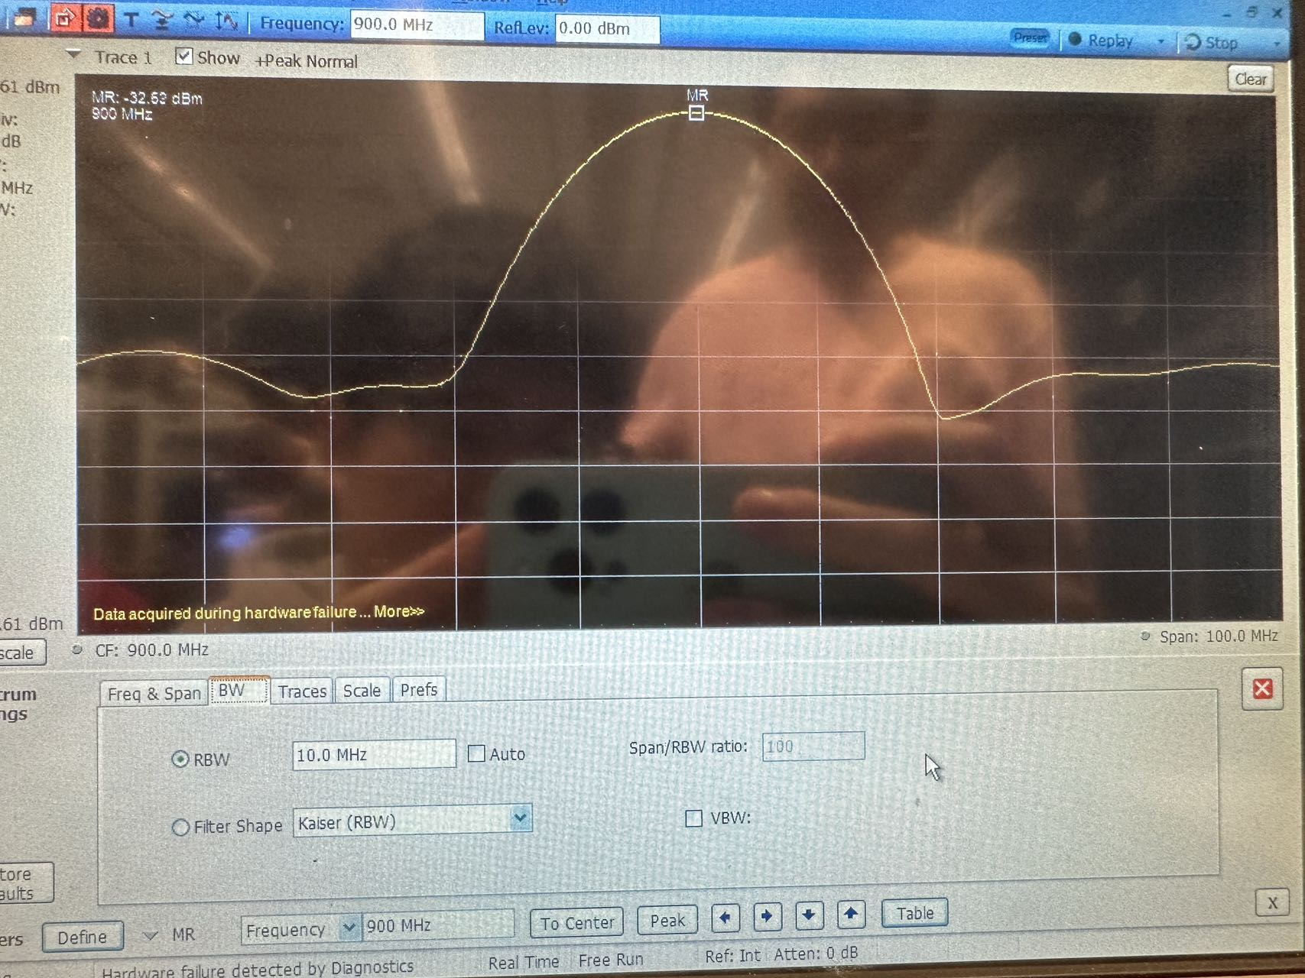

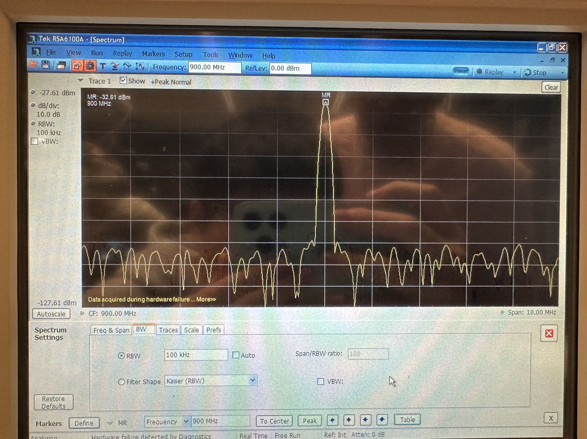

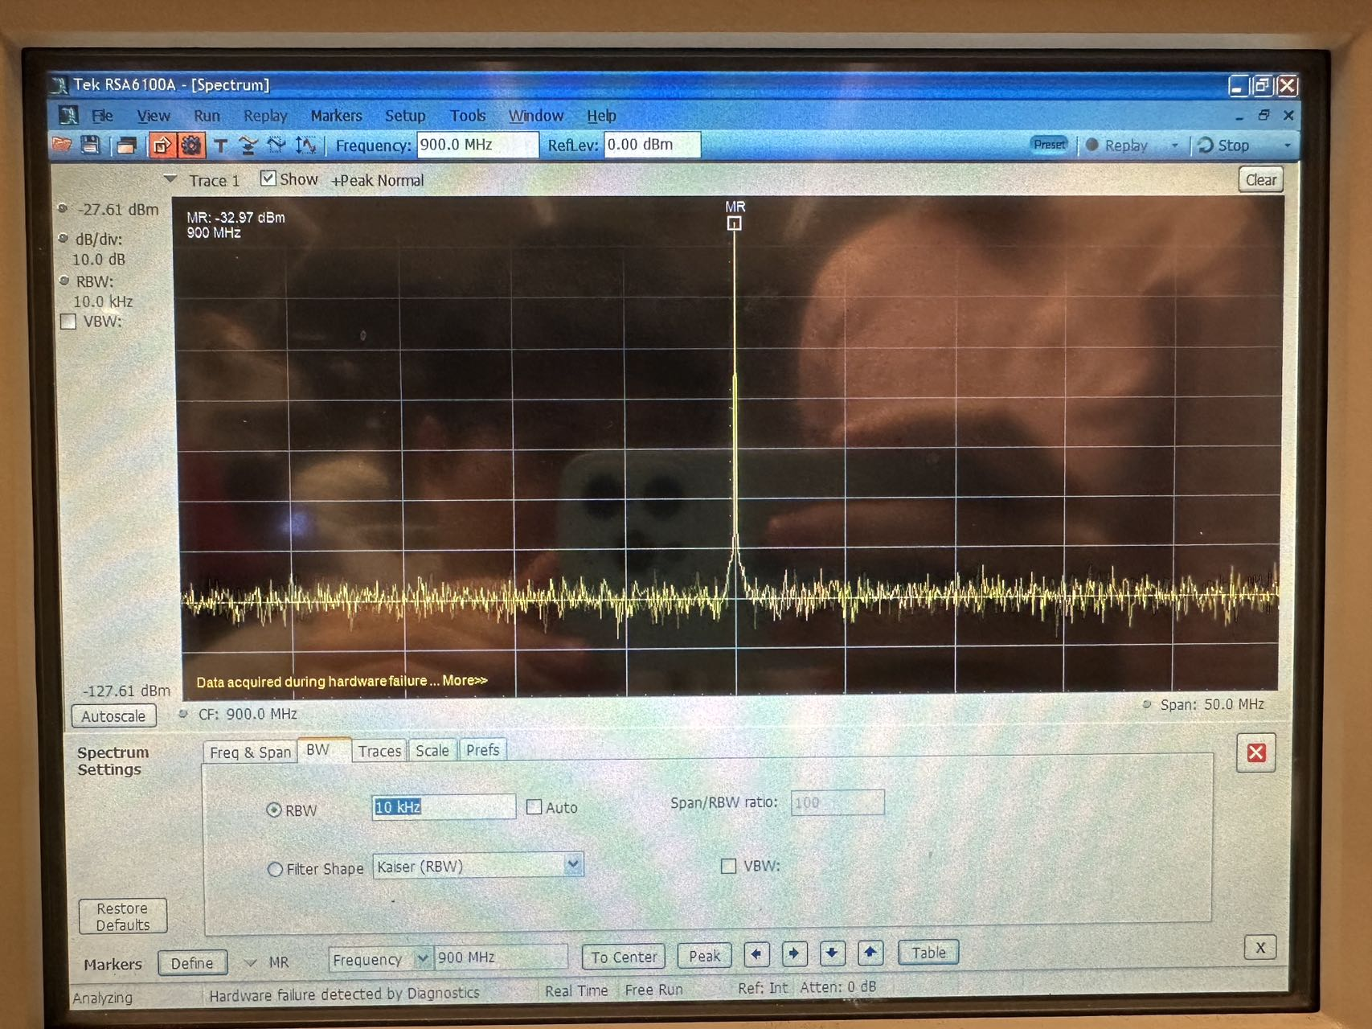

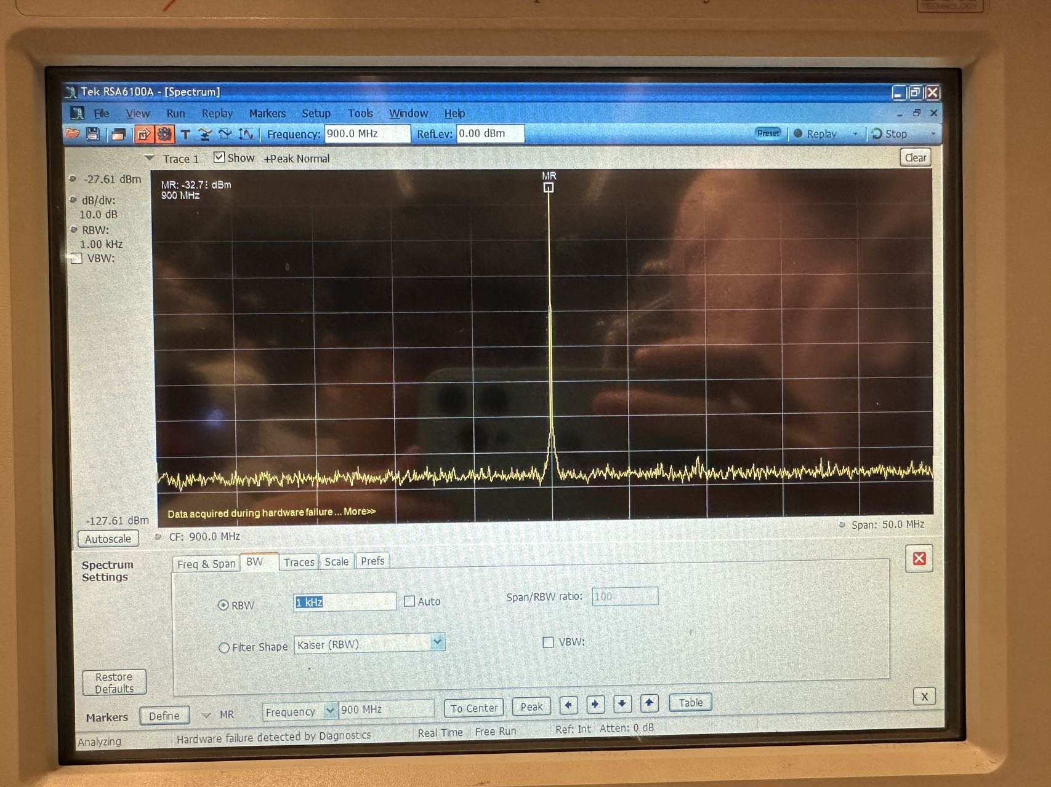

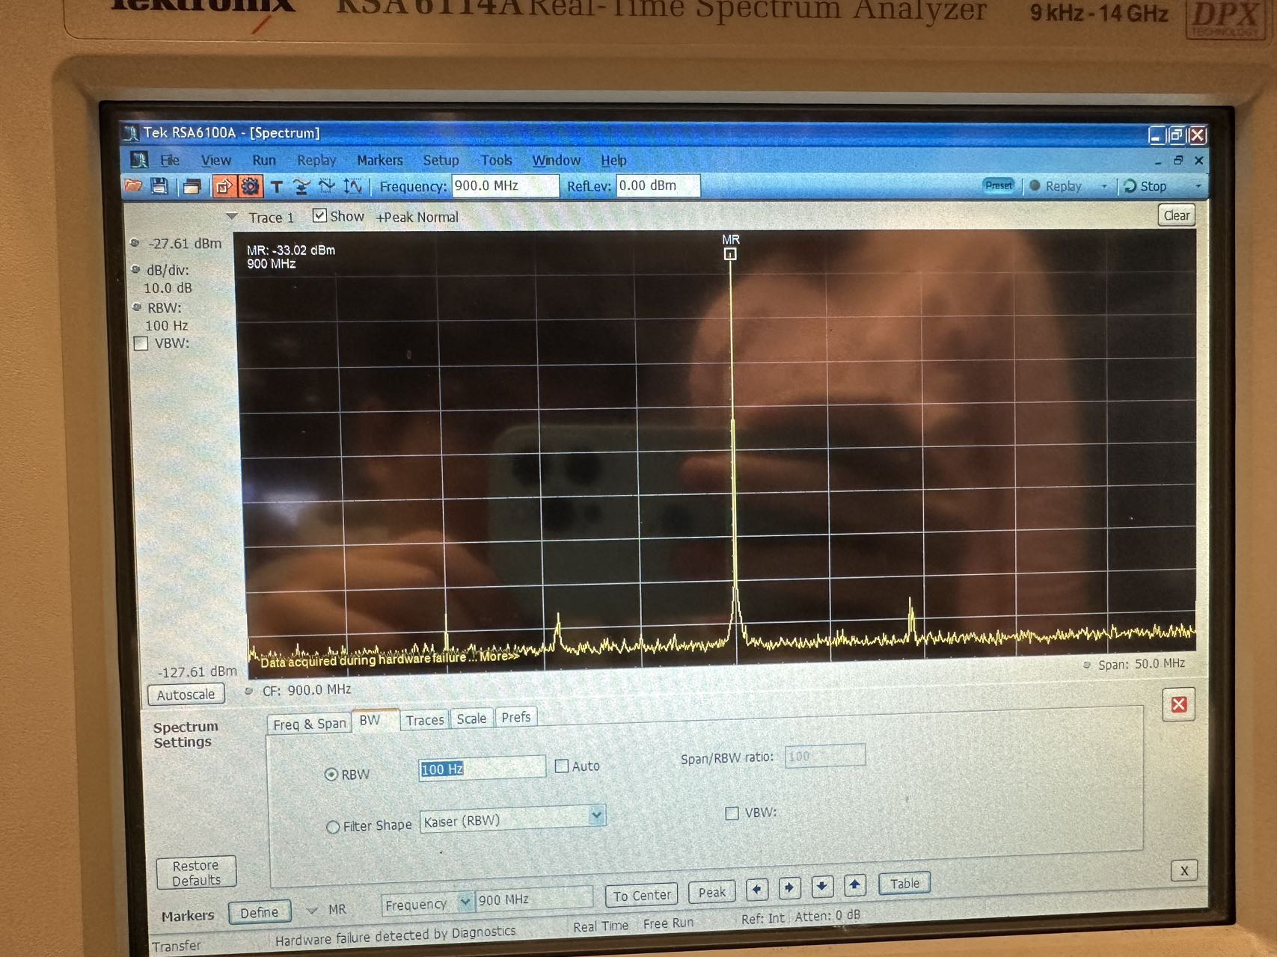

A narrow RBW provides finer frequency resolution. It allows the spectrum analyzer to distinguish between closely spaced frequency components, which is crucial for observing and measuring narrow spectral features or closely spaced signals. It also lowers the noise floor of the spectrum analyzer, enhancing sensitivity to weaker signals. This is because a narrower bandwidth filters out more noise.

A wide RBW results in poorer frequency resolution. Signals that are close in frequency may blend together, appearing as a broader signal. This is less advantageous for distinguishing closely spaced spectral lines. It also raises the noise floor, making it harder to detect low-level signals, as a wider bandwidth integrates more noise.

1. Connect the signal generator output directly to the spectrum analyzer. Set internal attenuator to 0 dB. Attempt to find the signal. Beside of selecting suitable resolutions bandwidth, you can also use spectrum averaging if it is available in your equipment.

You can also smooth the noise by setting suitable video ﬁlter bandwidth.

In Tektronix the spectrum averaging is activated in spectrum view by Settings button. In Traces tab set Function value to averaging Avg (VRMS) and by select samples size for instance 100.

Hint: The time required for scanning can be reduced by reducing the monitored bandwith area (span). Measure and record the noise floor level.

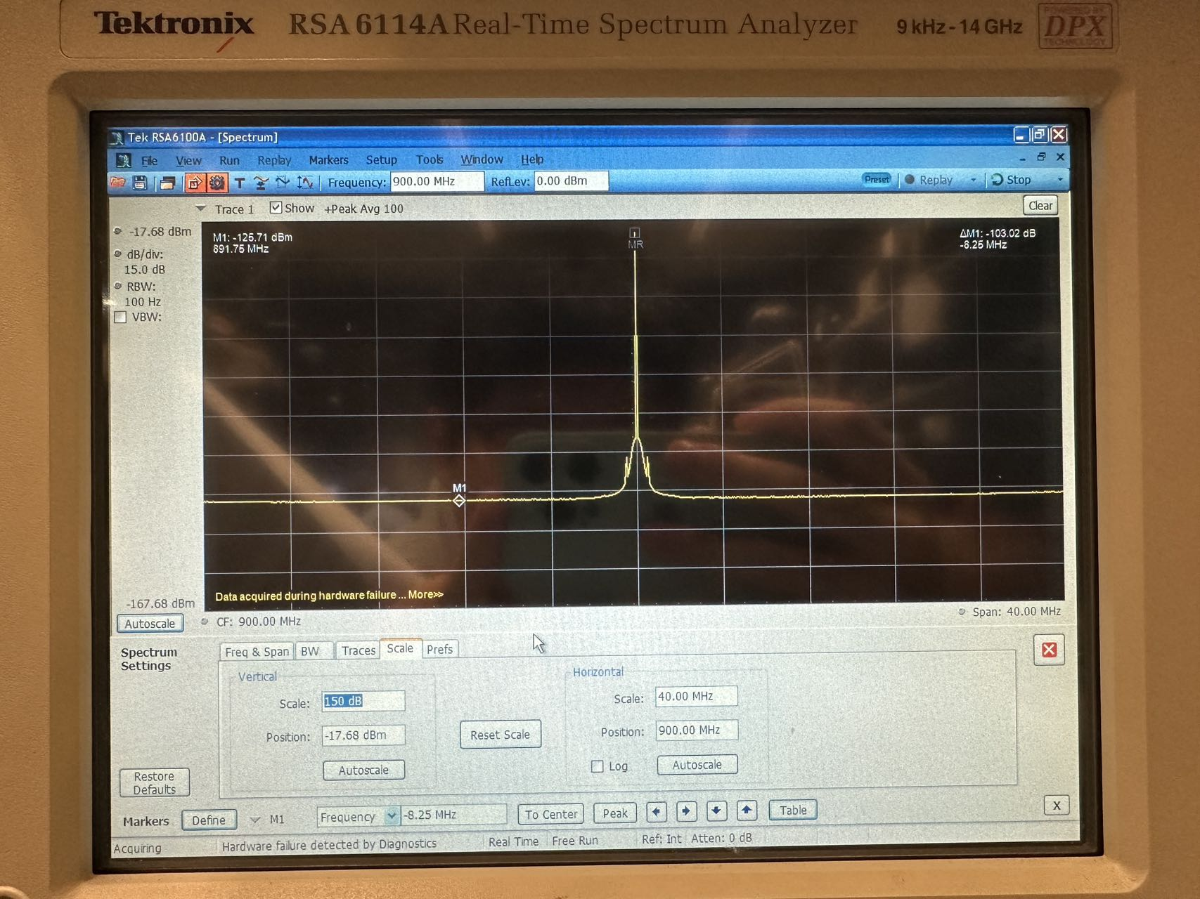

The noise floor level is -125.71 dBm.

1. The impact of resolution bandwidth on the noise ﬂoor level can be removed by normalizing the noise floor value to one Hz. For that you have to remove from the measured noise floor level the resolution bandwidth 10log(RBW) dB. Use that approach and compute the noise floor per Hertz? Insert it into final report.



In question 10 calculated noise ﬂoor consists of thermal noise and spectrum analyzer components own noise (noise ﬁgure). The thermal noise can be calculated as



where  is Boltzmann’s constant, *T* is the temperature in Kelvin, and *B* is bandwidth in Hertz.

1. Assume the temperature is 290 K. Calculate the spectrum analyzer’s noise figure.

The thermal noise can be calculated as



The measured noise floor level moved resolution bandwidth



Hence, the spectrum analyzer’s noise figure is



1. Set the spectrum analyzer internal attenuation to 0 dB and examine QAM signal. What is the signal bandwidth? What signal generator option determines the necessary bandwidth?

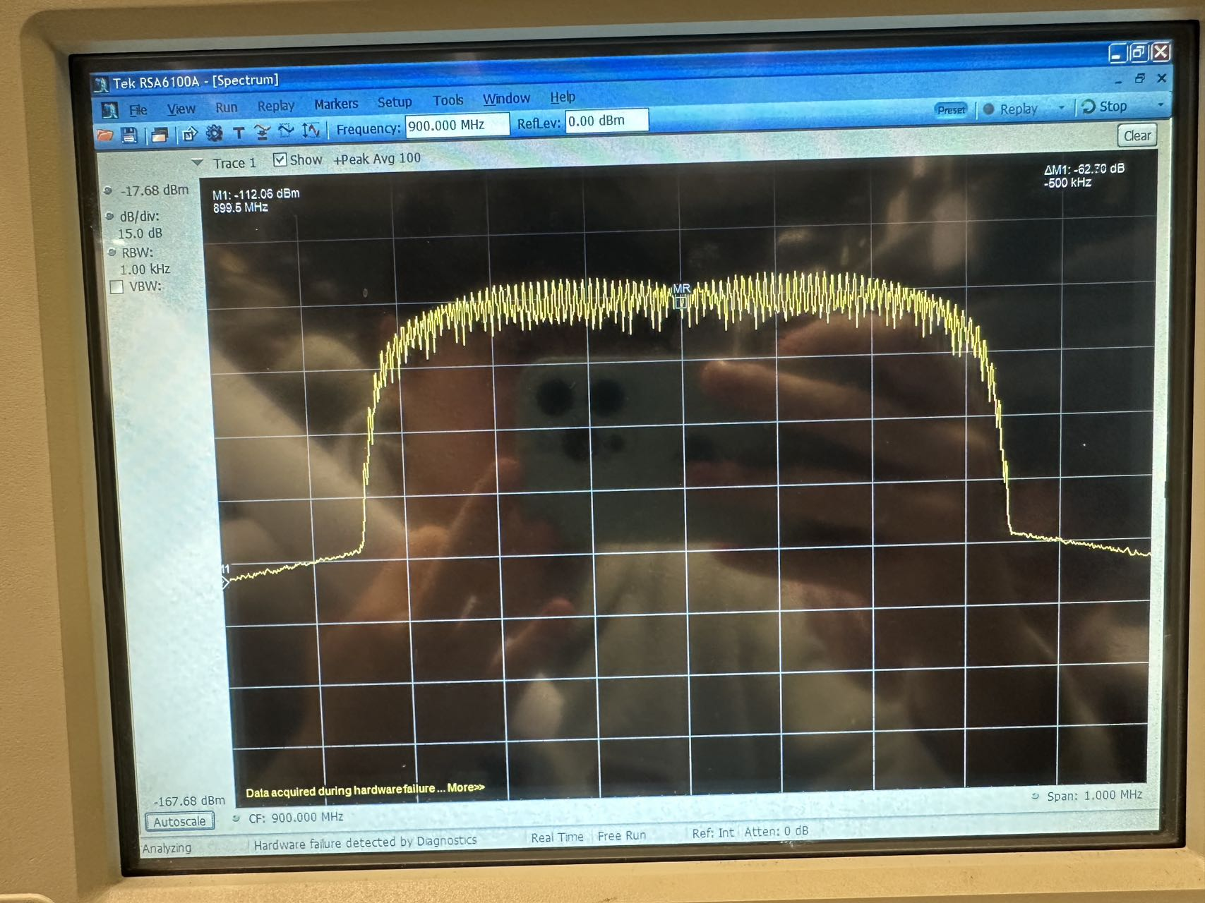

The signal bandwidth is approximately 700kHz.

The bandwidth required for the signal is primarily determined by the symbol rate setting on the signal generator. The symbol rate dictates the speed at which symbols are transmitted.

1. Set constellation view such that the constellation points should be clearly visible.

Are the constellation points equally distributed? Why/or why not?

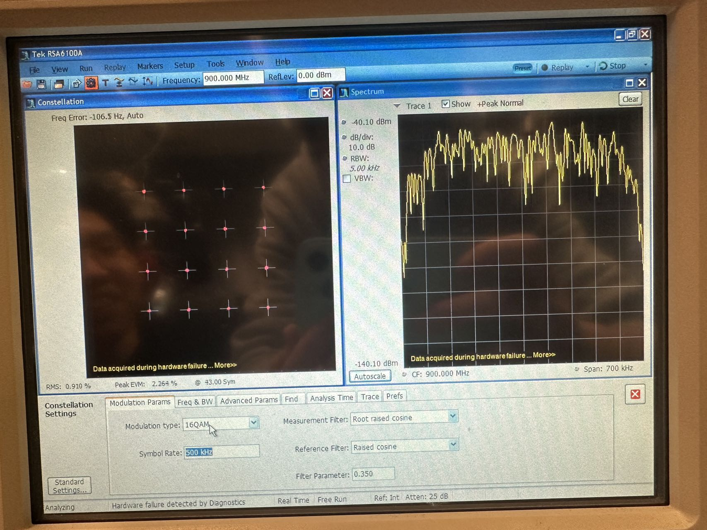

The constellation points are uniformly distributed. This uniform distribution represents the different symbol states, with each point corresponding to a unique combination of phase and amplitude. The equal spacing ensures that each symbol state is equally probable and that the receiver can distinguish between them with maximum efficiency.

1. Measure the channel power by averaging over 100 samples and by disabling "Channel ﬁlter". Compare the analyzer measured channel power to the power set in signal generator. How the signal power calculation of power now is different from signal power estimation from the voltage measured by oscilloscope?

The spectrum analyzer measures power directly in the frequency domain, considering the entire bandwidth of the signal and all its frequency components, including any harmonics or noise components. In contrast, the oscilloscope measures voltage in the time domain and requires conversion to estimate power based on RMS voltage. The oscilloscope's voltage-based method primarily focuses on the fundamental frequency component, especially in the case of sinusoidal signals. Therefore, differences in the measurement results can arise.

1. **Using spectrum analyzer**
2. Why we use sometime wide resolution bandwidth (RBW, RB). At narrow resolution bandwidth the spectrum analyzer can separate more frequencies and noise level is also reduced. Why then sometimes is better to use wide resolution bandwidth, what problems arise when we use too narrow resolution bandwidth?

A wider RBW allows for a faster sweep across the frequency range. This is because the analyzer spends less time measuring each point, making it an ideal choice for quickly scanning a broad frequency range or in applications where time is a critical factor. Wide RBW can be beneficial when analyzing transient or rapidly changing signals, as a narrow RBW might miss these short-lived signals due to its longer dwell time at each frequency point. Wide RBW provides a broader view of the spectrum, helping in initial scans to identify the presence of signals, peaks, and general spectral shapes before proceeding to detailed analysis.

Narrow RBW settings significantly increase the time it takes to sweep across a frequency range, which may be impractical for real-time or rapid analysis. Over long measurement periods, there is a risk of missing transient signals or rapid changes in the signal, and temperature variations or other environmental factors might cause drift in the signal or equipment, potentially affecting the accuracy of measurements. Narrow RBW might lead to underestimation of signal power, especially for signals with complex modulation schemes or pulsed signals, where the energy is spread over a range of frequencies. Moreover, narrow RBW can make the measurements more susceptible to phase noise and frequency stability issues of the spectrum analyzer's local oscillator.

1. Show by equations what frequencies are generated by multiplication of two frequencies *fLO* and *fIF* in equation 7.

In equation 7



When two frequencies are multiplied, they generate two new frequencies: the sum and the difference of the original frequencies:



1. Why the spectrum analyzer is connected through directional coupler and not by measurement probe, like it is used in oscilloscope connection?

Spectrum analyzers are typically used to measure high-frequency and radio frequency (RF) signals. These signals require different handling compared to the lower-frequency signals usually analyzed by oscilloscopes. Directly connecting a probe to a high-frequency signal can significantly disturb the signal. A directional coupler allows for signal sampling without substantial interference or alteration of the signal path.

Directional couplers provide isolation between the device under test (DUT) and the spectrum analyzer. This isolation is crucial for protecting the analyzer from high power levels that could potentially damage its sensitive input circuits. The coupler minimizes the load effect on the circuit being tested. Unlike probes that can introduce significant capacitance and loading effects, directional couplers have minimal impact on circuit performance. For power measurements, especially in RF applications, the directional coupler accurately couples a known fraction of the power flowing in one direction. This is essential for precise power measurements and for ensuring that reflections and standing waves are correctly accounted for. Directional couplers are used to sample the signal for analysis while allowing the majority of the signal to continue to its intended destination. This is particularly important in RF and microwave systems where maintaining the integrity of the signal path is crucial.

**Remote control of measurement equipment**

Remote control by using Telnet connection

The screenshot of the commands and responses are as follows,

After the command '*RST' and '*CLS' we could find that the signal generator is reset.

After the command 'SYST:SERR?' we could get the respond that there is no error.

There's on observing respond after the command which the title is 'BB:ARBitrary:TSIGnal:RECTangle:' with unknown reasons.

After the command 'FREQuency 100000000' and 'LEVel -25', we could find that on the screen of signal generator, the frequency of signal was set to 100MHz, and the signal level was set to -25dB.

After the command 'BB:ARBitrary:STATe 1' and 'OUTPut:STATe 1', we could find the signal wave on the screen of oscilloscope.

Time domain measurement with PyVisa python program

According to the file tdanalysis.py, we could find that the set generator signal frequency is 100MHz, the set attenuator attenuation value is 10 dB, the time horizontal scale in the oscilloscope is 5ns.

After running the program, the screenshot (photograph) of the result could be seen as follows,

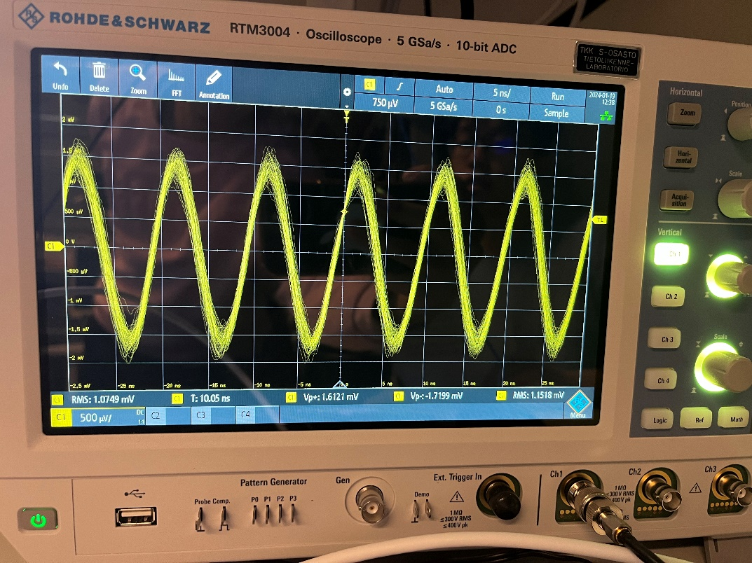

We could see 23/4 signal periods in the screenshot.

Changing the code such that the signal generator generates 40 MHz sinus signal, we could see the result as follows,

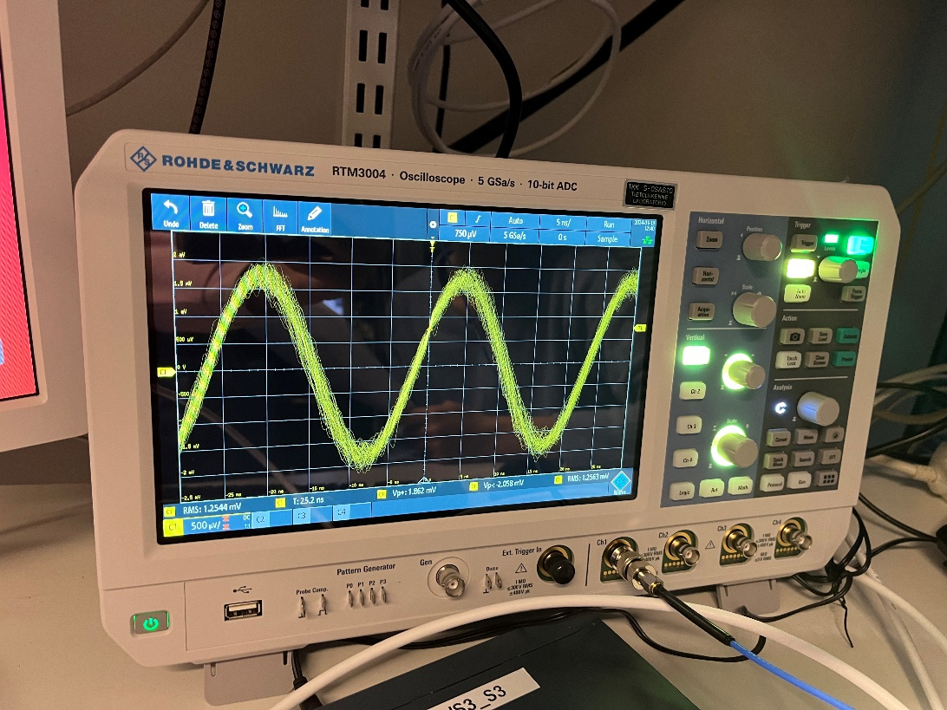

We could see that the amount of signal periods changed to 9/4.

Frequency domain measurement with PyVisa python program

When the values are the default value in the program (attenuator attenuation value equals to 10dB, signal power level of generator equals to -10dBm), theoretically, if we could ignore the cannel transmission loss, the receive signal power should be -20dBm.

But we could see the result from experiment that the receive signal power is -50dBm.

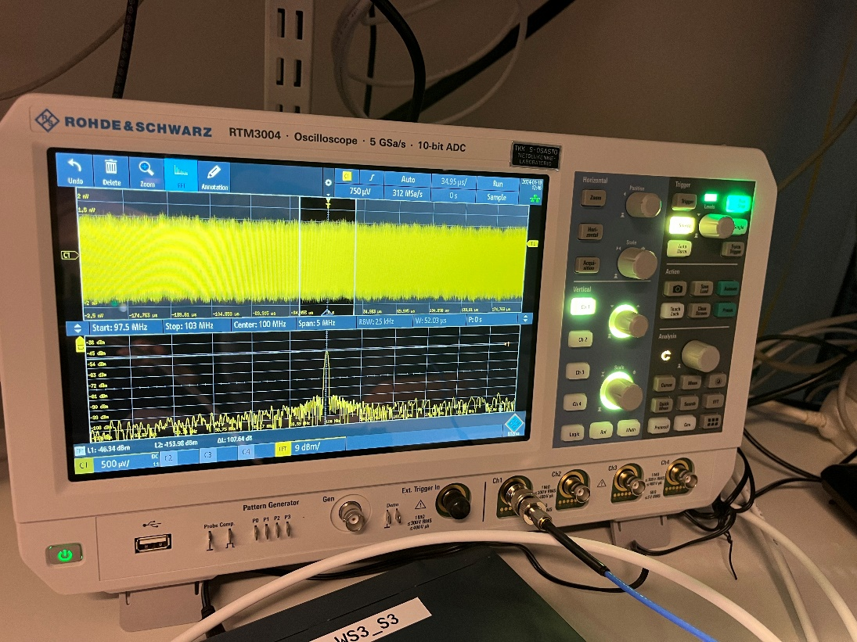

Changing the attenuator values to 15dB, we could find the result as follows, the receive signal level is about -54Bm.

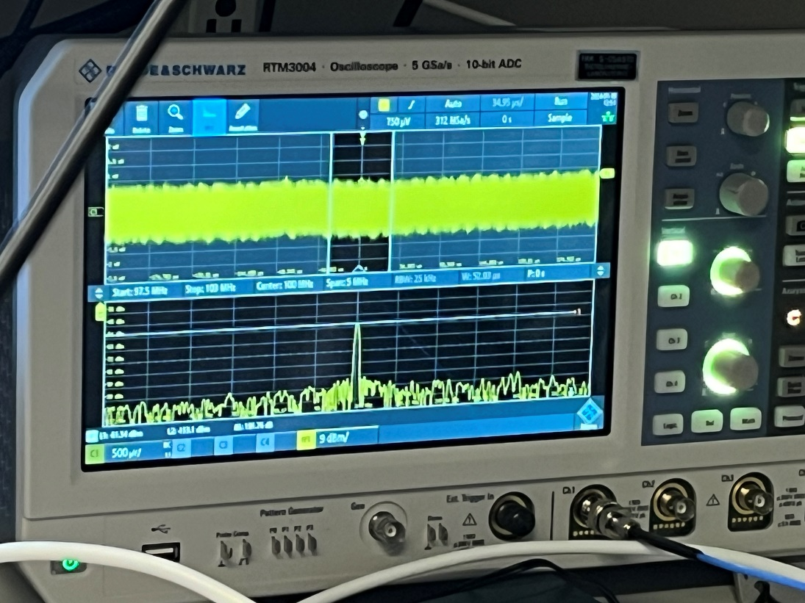

Changing the attenuator values to 20dB, we could find the result as follows, the receive signal level is about -60dBm,

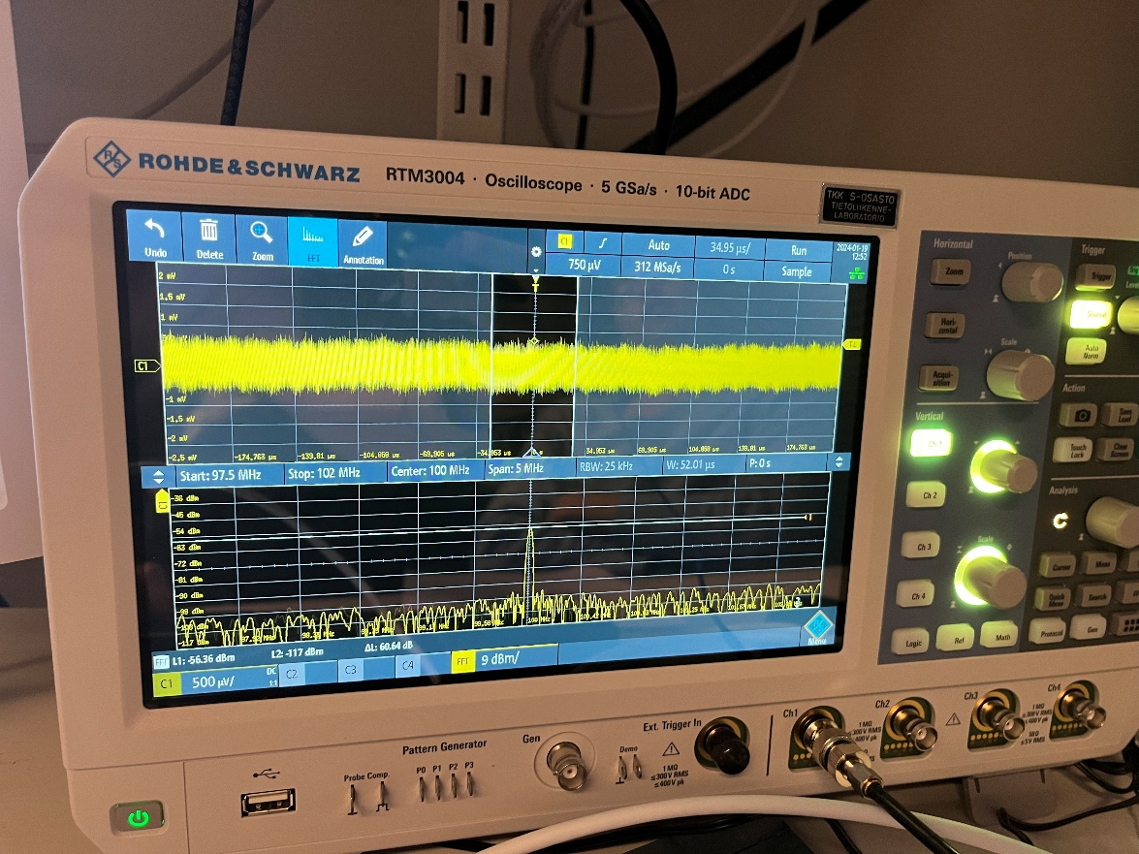

Changing the attenuator values to 25dB, we could find the result as follows, the receive signal level is about -64dBm,

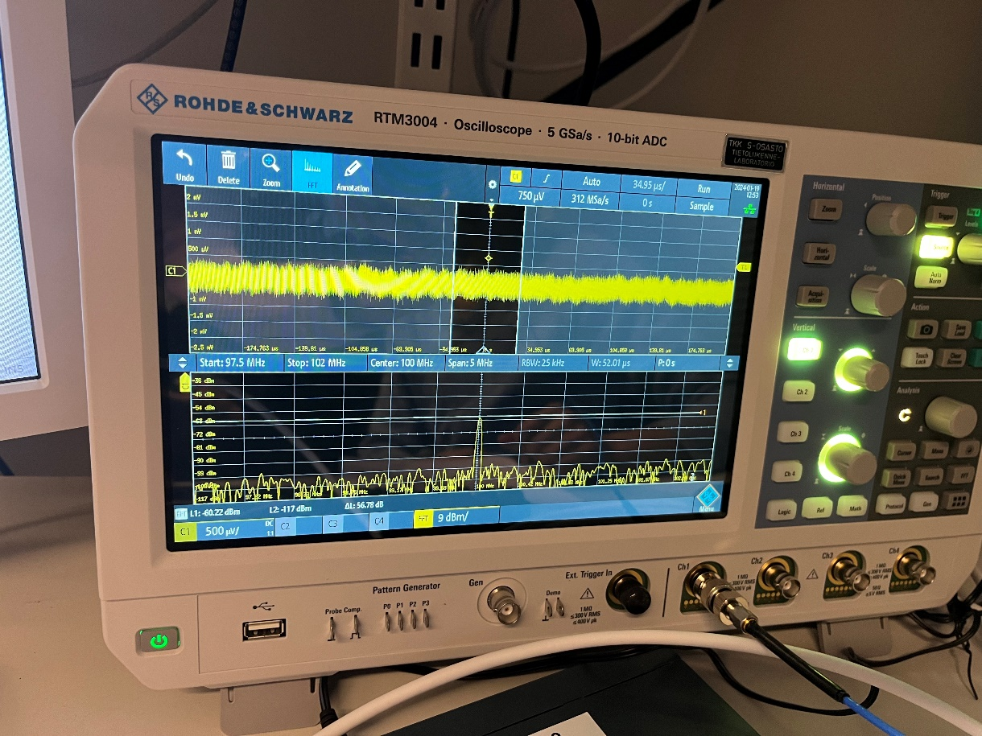

Changing the attenuator values to 30dB, we could find the result as follows, the receive signal level is about -70dBm,

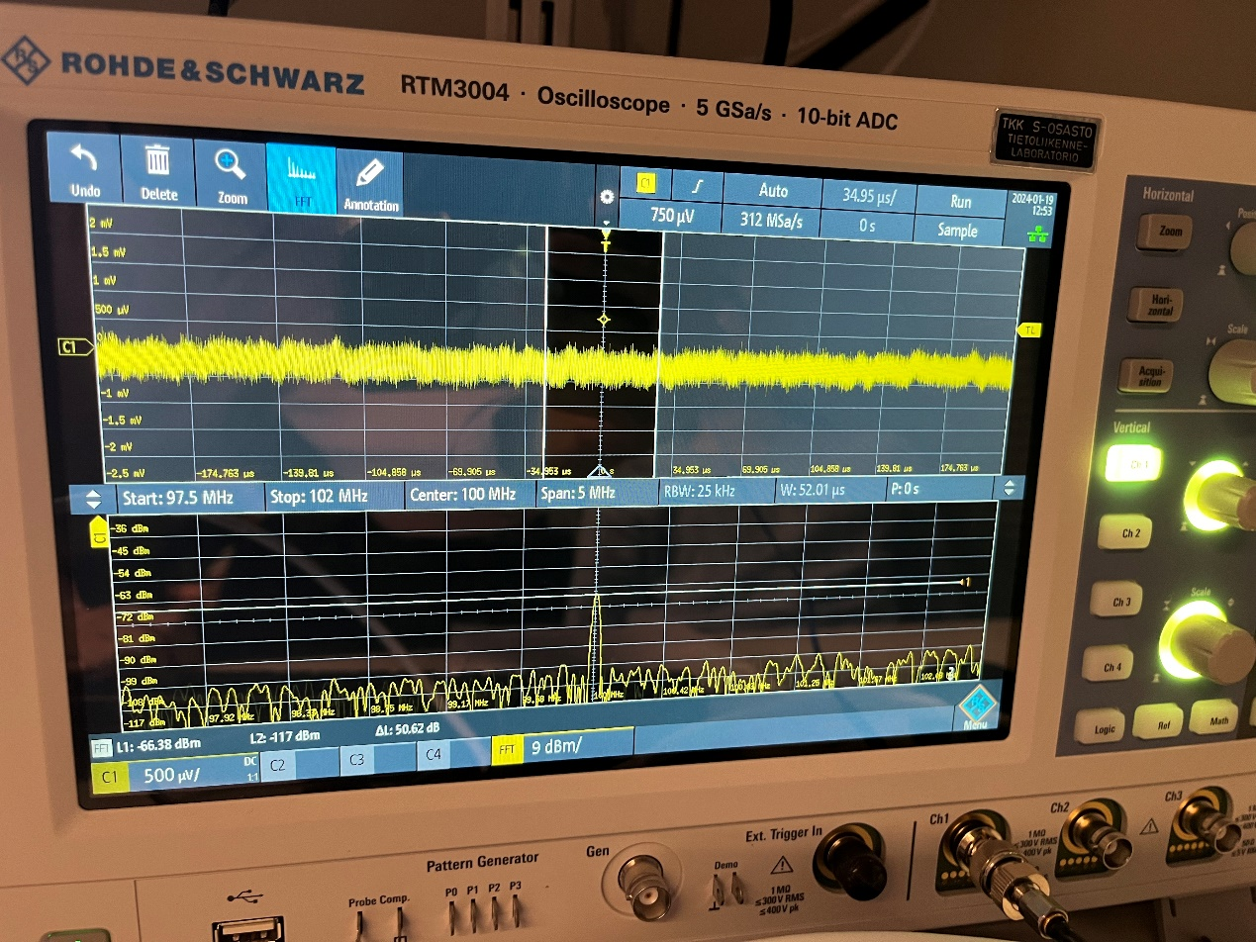

We could get the table containing the theoretical estimated signal levels at the oscilloscope and the measured signal powers as follows,

|  |  |  |  |  |  |
| --- | --- | --- | --- | --- | --- |
| Attenuator values/dB | 10 | 15 | 20 | 25 | 30 |
| Theoretically received signal power/dBm | -20 | -25 | -30 | -35 | -40 |
| Received signal power/dBm | -50 | -54 | -60 | -64 | -70 |

According to the theoretically values and the actual values, we could judge that the loss on signal pass is about 30dB.